**TRAINING AND PLACEMENT CELL MANAGEMENT SYSTEM**

A Java project regarding Training and Placement Cell management system



Link to project: https://github.com/Chakri7reddy/TNPCM

z

A Training and Placement Cell Management System (TNPCM) based on

Java, MySQL, JSP, HTML, CSS

Lokireddy Chakridhar Reddy, Princi, Kuldeep Pal -CS3P G1, CSE: CSP116

Under the Guidance of Mr. Murari Kumar Singh

*Project done and nourished in the subject of “Project Based Learning” in Sharda School of Engineering and Technology, Sharda University, Uttar Pradesh*

# **A R T I C L E I N F O**

***Keywords:***

* Training and Placement Cell Management System
* Companies’ management
* Web Based Application Intelligent system
* Certificates’ management
* Automated Iodation
* Internship Info
* Web Site
* Accuracy
* Admin and Student

# **A B S T R A C T**

Any academic group must region an excessive precedence on schooling and location (T&P), but this procedure is regularly executed manually utilising paper-primarily based totally systems, databases, spreadsheets, and email. With the assist of an internet utility this is being created, the T&P procedure might be automated, growing productivity, security, and abstraction even as requiring much less guide labour.

Students and T&P officers (TPOs) with the proper login credentials will each be capable of use the utility. Once they've registered, college students can also additionally get admission to the utility to look at the necessities for imminent placement drives, get admission to technical and flair checks applicable to positive firms, and replace their non-public statistics. TPOs could have get admission to pupil information via the program, which they also can use to acquire resumes and perform different placement-associated duties. By growing software program that controls placement sports with a user-pleasant GUI, we're setting forth a smart and easy answer for placement sports. The purpose of this venture is to create a gadget that a college`s placement mobiliary can also additionally use. Designing a gadget with functions to perform placement-associated tasks, together with displaying pupil and corporation statistics to each other and imparting a verbal exchange interface among the 2 events is our TPO's purpose.

In this paper, we have impeded the basic security for this and our database can handle over a large group and makes it use very simple. The basis of software program improvement is a completely modular design. Because of the architecture's flexibility, we can be capable of modify or upload modules withinside the destiny to enhance a positive characteristic or circumstance. Main motive of this venture is to offer a pleasant get admission to its user, can also additionally or not it's a pupil, a schooling and location officer or any authentic of the college. Students might be without difficulty feeding there required information into the gadget after which the TPO also can without difficulty fetch the desired matching pupil details. We used Eclipse IDE for Enterprise Java and Web Developers 2023-03, MySQL Workbench 8.0 CE, MySQL Connector and many more. To be able to have this opportunity to represent our team to bring success to this project is regarded such a great achievement to our team and members.

# **INTRODUCTION**

In the current climate, it's essential for scholars to be suitable to pierce and complete the operation form with a single click. Despite this, the training and placement system is still managed manually.

Managing learning integrated into internships and work has long been supported by paper-based systems, databases, spreadsheets, and email communications.

Unfortunately, in today's fast-paced world, most of these are not flexible enough to change and cannot respond quickly enough, especially outside of business hours . It is also labour intensive. Many listing websites provide information but do not have interactive features that allow you to take action on the information provided.

The project's goal is to create a web application for our university's Training and Placement division. The thing is to automate the system and give directors with the capability to keep the details of scholars up- to- date. The use of the Internet allows the Placement fellow to manage the placements process with the scholars' involvement. Both teachers and students have access to this internet application for work purposes from anywhere in the college. The college's Training and Placement department can utilize this system as an application to manage student data related to placement and training.

Arrangement handle is exceptionally troublesome to handle because it includes a part of information. Our proposed work gives the office to the understudies for seeing the work, applying for the same and sharing the involvement, which offer assistance the understudies to get ready themselves for the interviews and offer assistance to extend the specialized information. Subtle elements of the companies are given to the understudies with the Qualification Criteria and other Necessities by the admin. The extreme objective of the Venture is to supply the understudies with clear data almost the companies, and secure the understudy information. This Project also provides the clear information about, how many students placed, Total number of students, Total number of companies visited. Individuals and activities are usually arranged according to a design or plan. The aim of the Institute Placement Cell is to provide the Institute students with a world-class education with employment opportunities in the leading organizations/industries. Additionally, the Placement Cell provides the students with numerous opportunities to cultivate their personalities through frequent training in soft skills like communication. To achieve goals, Placement Cell works to assess students' core competencies.

The functionality of the system has demonstrated ease of use and flexibility, especially for students, internship providers, and administrators. All of the students' personal data, including contact information, academic information, corporate information, placement information, and eligibility requirements for students qualified for particular companies, is stored in the system. In this way, the objective of Preparing & Arrangement Cell is to supply business openings & world course preparing to understudies in driving organizations. The understudy entrance contains his/her points of interest of all the exams that he /she has composed till date in his career, which gives his/her quality and shortcoming. He/she can upgrade their CV into the entrance, which contains individual points of interest, and same thing can be shared by the admin to the different enlistment companies for contracting the understudies as per their prerequisites and based on the abilities of the students[1].

# **2.LITERATURE SURVEY**

Understudy Training and Placement Cell Management System (TNPCM) gives a basic interface for upkeep of understudy data. It can be utilized by Preparing & Situation officer of instructive establishing or colleges for getting to students’ records as per the situation criteria. The creation and administration of exact, acquainted data with respect to a student’s scholastic career is basically imperative within the college as well as in arrangement cell. Understudy Mechanization Framework bargains with all sorts of student's fundamental data, scholarly subtle elements, account points of interest and situation points of interest as well. It will moreover have workforce, staff and admin modules for keeping up and overhauling the understudy records. Staffs keep up the understudy subtle elements, account points of interest and make understudy ID and secret word, whereas staff overhauls their particular instructive and scholastic subtle elements and illuminate understudies by means of mail. It too encourages understudies to view their scholarly subtle elements. The foremost reason of this TNPCM is to decrease the utilization of time in the midst of keeping up the records of understudies and enlighten them through mail. Without an Understudy Computerization System, supervising and keeping up the focuses of intrigued of the understudy may be a tedious work for any educator institution or organization. Understudy Mechanization System will store all the focuses of intrigued of the understudies tallying their establishment information, teacher capability, person focuses of intrigued, sessional marks, college marks and all the information related to their proceed. SAS may be a web application that can be gotten to all through the organization and outside as well with demonstrated login given. This system can be utilized as an instrument for the HR of the college to induce to the understudy information with regards to situation[2]. Computer based information system are arranged to move forward existing system. HR can educate the understudies roughly the enrolment online through sending mail. So, the staff can besides advise the understudies around the marks, take note and account information online by implies of mail. Move forward precision in result. It has client neighbourly interface having quick confirmed get to the records. It gives the workforce of keeping up the educator focuses of intrigued of the understudies. It gives the staff of keeping up the unused understudy, account focuses of intrigued of the understudies.  It will diminish the paper work and use the maximum capabilities of setup and organization as well because it will spare time and cash, which are investing in keeping up reports and collecting information. This framework can be utilized as an application for college to administer the understudy records concurring circumstance. In an existing framework, all shapes at the time of course of activity of understudies are taken care of physically by getting to the understudy data from particular office, which is remarkably direct and eating up much tries and time. This get prepared is so troublesome when the number of clients increment. There are any limitations for the existing framework, in manual HR; all the work done at circumstance cell is by human mediations due to which there were more chances of botches. Looking is done physically based on the company criteria HR will recognize the qualified understudy by looking the surpass desires sheet. HR got to see each and each understudy marks and their capability. No looking strategy is given. The understudy will get teach through standard procedure i.e., utilizing take note board. There may be chances of hardship of opportunity. The understudies were not being made cautious of the ADMIN activity. Since the number of understudies are making and organization must handle records of all understudies. It is going up against a small bit issue in keeping up the records of understudies. It is required to orchestrate of a computerized understudy mechanization module to speed up capability [3].

# **3. PROBLEM STATEMENT**

The current system requires students to choose a particular university where their internship will take place and all these documents need to be kept, which creates a lot of space.

This is done manually, so documents may be missing and student data is difficult to handle. The TPO must manually maintain records for all students and her companies, but this requires a lot of paperwork, which puts students at risk of being misplaced, and of eligible companies. Students do not have the opportunity to apply to companies[4]. Therefore, this work must be done entirely digitally. Therefore, our main goal is to eliminate all paperwork using the software, which stores all records and gives all qualified students the opportunity to apply to companies. The existing system was completely handmade. Training and deployment personnel must manually review records, often resulting in increased paperwork. This manual search is very tedious and time consuming. This process works well for a small number of students, but the overhead increases as the number of students increases. Manually updating and deleting records to get the desired result is likely to result in errors[5].

Campus internships are now offered daily at all universities. Various software companies and other industry companies conduct campus selection processes to select candidates based on performance. All student data is managed by the admin manually by the and our software will automate the data in the . Additionally, this project aims to facilitate students' registration and personal contact with the Career Support Office. Users have easy access to information and data is readily available. The main page has login and login options. Registered students can log in directly using username and password to upload their resume. Student information has fields for personal information and academic background. Job details of her students placed are provided through the administrator permission. Two of her administrators play an important role in our project. From checking 's information to updating her student's information[6].

# **4. TECHNOLOGIES**

* Java, SQL, HTML, and CSS are common innovations that can be utilized to create preparing and arrangement cell administration frameworks. Java may be a general-purpose programming dialect appropriate for creating web applications. It's vigorous, adaptable, and secure. Java is additionally utilized to create numerous prevalent systems and libraries such as Spring Boot and Rest, making improvement simpler and speedier. SQL may be a database dialect utilized to store and control information. Used by most well-known databases such as MySQL, PostgreSQL, and Prophet. SQL is essential for creating applications that ought to store or manage information. HTML could be a markup language utilized to make web pages. Utilized to characterize the structure and substance of web pages. HTML is simple to memorize and utilize, and is bolstered by all major web browsers. CSS may be a fashion sheet language used to control the appearance of web pages[2].
* Utilized to characterize textual styles, colours, and format of web pages. CSS can make your site more outwardly engaging and user-friendly. Underneath is an outline of how these innovations can be utilized to create preparing and situation cell administration frameworks.
* We'll be able create the backend of our framework utilizing Java. This incorporates the code that interatomic with the database, forms client demands, and produces reactions.
* Utilize SQL to store and manage information approximately understudies, companies, and internship openings.
* We'll be able create the front conclusion of the framework utilizing HTML and CSS. This too incorporates a client interface for understudies and businesses to interact with the framework. Here are some concrete illustrations of how we’ll utilize these advances in our ventures.
* We’ll use Java to create servlets to handle login and verification demands.
* We can utilize SQL to store and retrieve student data such as name, contact data, and scholarly foundation.
* Utilize HTML and CSS to develop web site where understudies can transfer their resumes and check out internship openings.
* In general, Java, SQL, HTML, and CSS are capable advances that can be utilized to create strong and adaptable preparing and placement cell administration frameworks.

# **5. IMPLEMENTATION**

*ARCHITECTURE AND DESIGN:*

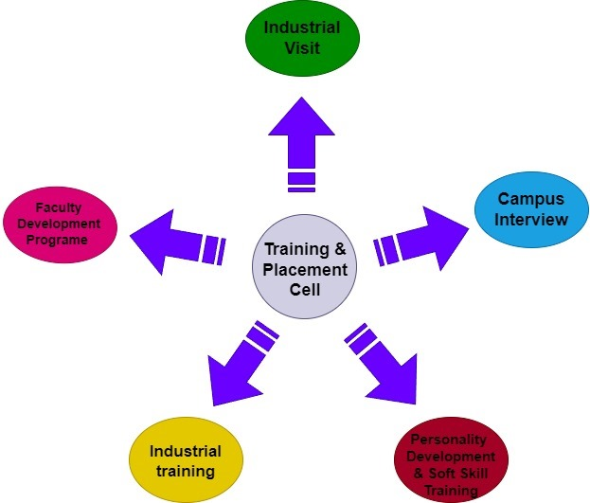

Traditionally, registration will done manually by handing out registration forms to students. But it took too long hours and was also inaccurate. Therefore, biggest need was to automate registration through online registration by students themselves. This project aims to develop the software for the university's training and placement department.

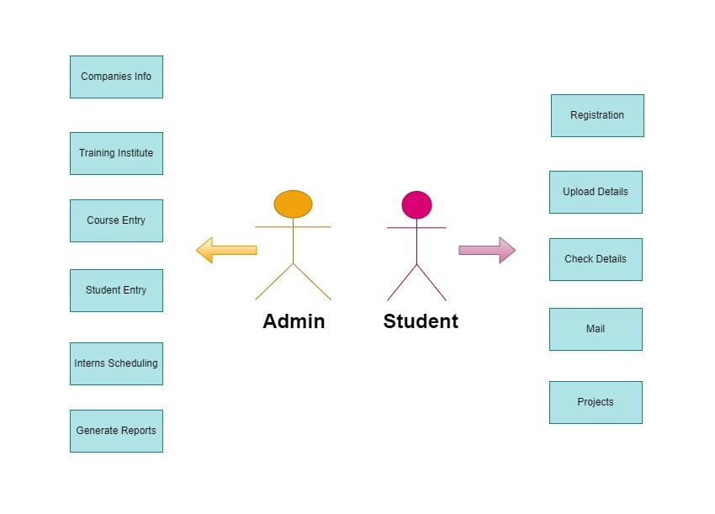

There are three types of users in our proposed system: students, company personnel, and TPOs. The TPO is the administrator of the system and can control all the software, including: Examples: Managing company information, student information, sending company standards notifications to targeted students and follow-up from both student and the company. Currently, the only notification method is bulletin board notification, which is unreliable. To resolve this issue, which can send notifications via email or mobile SMS.

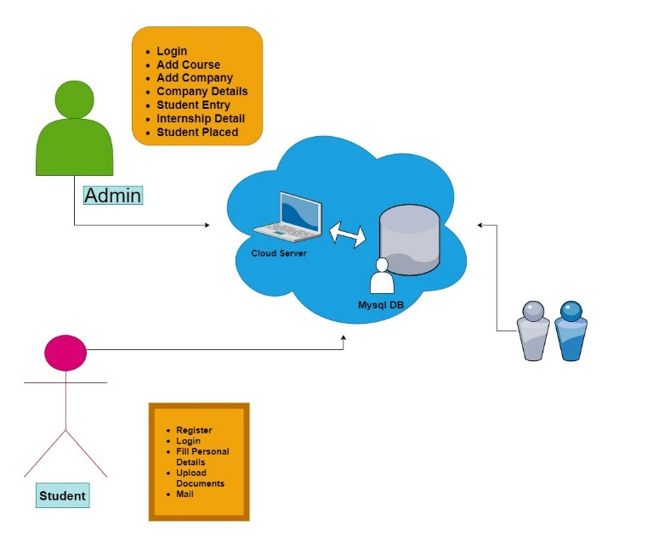

The TPO tab first shows the login page. Starting with, TPO has a unique login ID and password (id-admin@gmail.com and password- admin@3456).

Then it displays a new page. This page includes tabs such as Student Details, Company Details, Create Listing, and Resume. The Understudy Points of interest tab permits the TPO director to see the points of interest for a specific understudy or the whole stream and enter the specified company details. The Produce List tab permits TPO directors to recover the complete list of understudies enrolled with a company and permits the chairman to part the list by company title. The Resume's tab permits an director to see a specific student's continue with the student's comparing ID. [8]

***IMPLEMENTATION:***

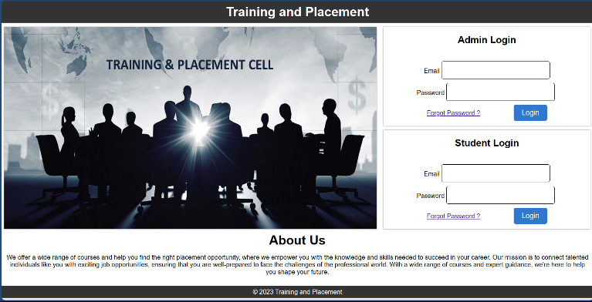

HOME_PAGE

The planning system is completely computerized and eliminates all shortcomings of the existing system. Here registered students can upload their details in the form of resume, certificates and transcripts.

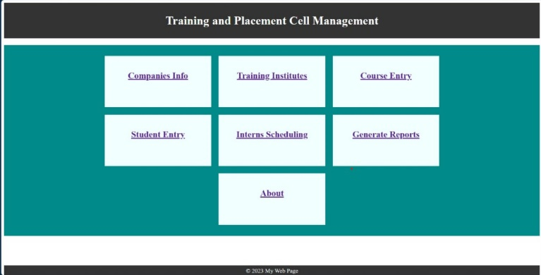

ADMIN_PAGE

The administrator creates the user and the user uses the account created by the administrator.

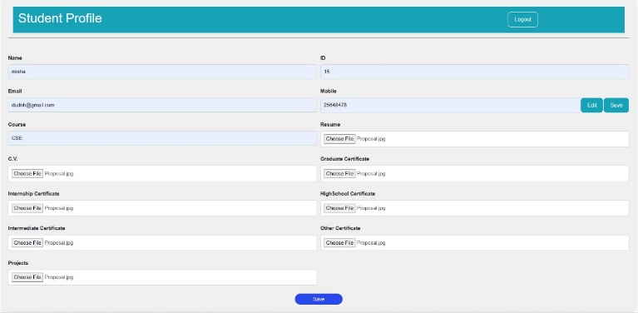

STUDENT_PAGE

Once the user visits the respective page, the details must be updated. And the details need administrator approval.

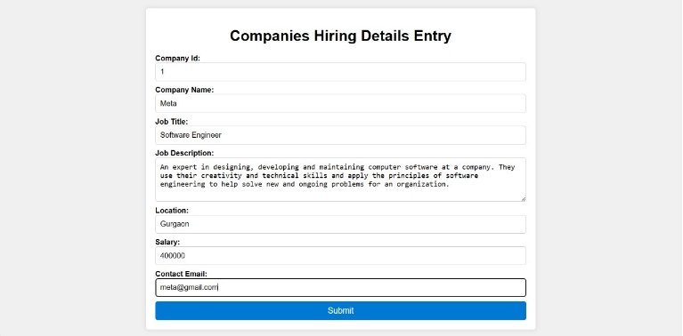

COMPANY_DETAILS_PAGE

All users can do some activities like change their password, update their details, find their details, check their details, send an email to the administrator, view materials uploaded by the administrator, etc. if the user is a student.

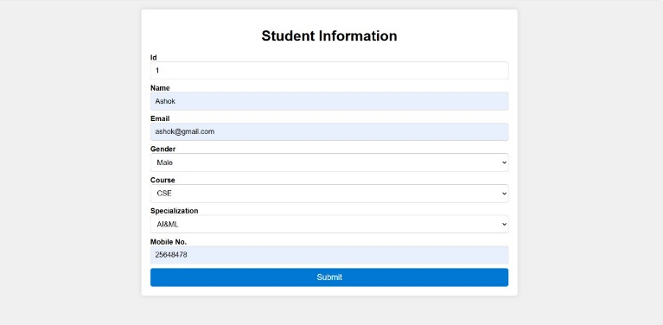

STUDENT_INFORMATION_PAGE

Common services are available. Administrators need to perform services such as adding Companies, events and achievements, and replying to emails sent by users.

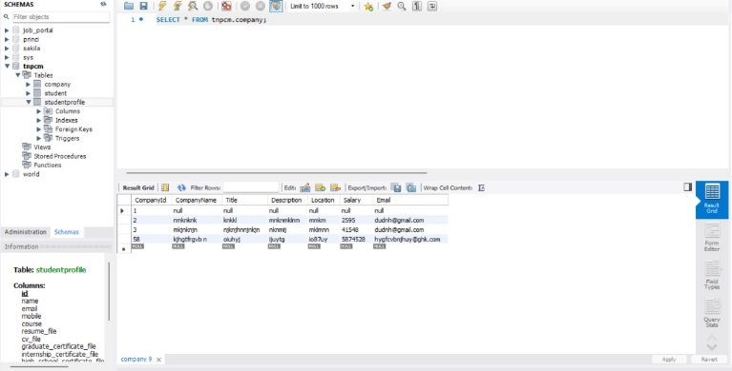

DATABASE_MANAGEMENT

Student has the right to upload materials, search student data and approve students.

# **6. OJECTIVES**

* **STUDENT FRIENDLY INTERFACE:**
  + Educational and placement cell system tells the details of each student.
  + Students cannot self-register for training and her placement using the registration form on the website.
  + Students and college staff can view result of their training and placement status.
  + A search function is available that allows students to view only their educational background and employment status.
  + This website is user friendly and has a more graphical user interface so students can easily register and view her information
  + The ability to alter personal and academic information, such as email addresses, current semesters, correspondence addresses, and grades from previous semesters, is available to students.
* **REAL-TIME COMMUNICATION:**
  + Provide appropriate communication channels between students and the Training and Placement cell management system using intelligent communication channels such as email and SMS.
  + Provides day to day current information about which main companies are regular visiting campus, helping students get up-to-date information to students quickly.
* **SECURITY MANAGEMENT:**
  + Ensures reliability by avoiding invalid duplicate registrations.
  + Only administrators can modify deployment and organization records if necessary.
  + Administrators are responsible for deleting all student records from the database.
* **FACILITATE STUDENT LEARNING:**
  + Helps in shortlisting students to be accepted into a particular company.
  + Helps students to understand the placement scenario in detail.
* Also helps in proper resume building[4][7].

# **7.FUTURE SCOPE**

The future prospects of Training and placement management systems are quite promising. As the world becomes increasingly digitized, more educational institutions, including Colleges and universities are actively exploring ways to enhance the efficiency and effectiveness of their educational and placement activities. A management system dedicated to training and placement can play a pivotal role in achieving this goal by automating various tasks associated with the training and placement process[8].

Here are some key technologies and areas that will shape the future of training and placement mobile management systems:

1. Artificial Intelligence (AI): AI can be harnessed to develop advanced Training and placement management systems that personalize the experience for both students and organizations. For instance, AI can recommend job openings to students based on their skills and interests, and match students with organizations according to their hiring needs.

2. Big Data Analytics: Utilizing big data analytics, these systems can derive valuable insights from the data collected, which can be used to enhance the efficiency and effectiveness of the education and placement process. For example, such analytics can identify students who may face difficulties in finding placements and enable the development of tailored programs to support them.

3. Mobile Computing: The increasing use of mobile devices for internet access demands that education and placement mobile management systems be mobile-friendly. This ensures that students and organizations can access these systems from anywhere, at any time.

Furthermore, integration with other systems, such as student information systems and enterprise resource planning (ERP) systems, is likely to become more seamless. This integration will significantly enhance the efficiency and accuracy of the training and placement process.

In summary, the future of training and placement mobile management systems holds great promise. As technology continues to evolve, these systems will become more sophisticated, integrated, and will play an increasingly critical role in the education and placement of students[9].

# **8.IMPACT**

A training and placement cell management system (TPCMS) can have a significant impact on both students and institutions. Here are some of the key benefits:

For students:

• Improved placement rates: A TPCMS can help students to better understand the placement process and identify suitable opportunities. It can also help them to track their applications and follow up with companies.

• Enhanced skills and employability: A TPCMS can provide students with access to training and resources to help them develop the skills and knowledge they need to be successful in the job market.

• Increased transparency and efficiency: A TPCMS can make the placement process more transparent and efficient for students. Students can access all relevant information in one place, and they can apply for jobs and track their applications online.

For institutions:

• Reduced workload for placement officers: A TPCMS can automate many of the tasks involved in the placement process, such as managing student profiles, posting job openings, and coordinating interviews. This can free up placement officers to focus on more strategic tasks, such as building relationships with companies and developing training programs.

• Improved data collection and analysis: A TPCMS can generate valuable data about the placement process, such as student placement rates, the most popular companies, and the skills that are in demand. This data can be used to improve the placement process and develop more effective training programs.

• Enhanced reputation: A well-managed TPCMS can help an institution to build a reputation as a leader in placement. This can attract more top students and companies[10].

|  |  |
| --- | --- |
| **PROS** | **CONS** |
| Efficiency | Cost |
| Centralised Database | Integration Challenges |
| Data Analysis | Technical Issues |
| Customization | Data Security |
| Scalability | Dependency |

Overall, a training and placement cell management system can have a positive impact on both students and institutions. It can help students to improve their chances of getting placed in good jobs, and it can help institutions to improve their placement rates and reputation.

• Promote diversity and inclusion in the workplace by making it easier for students from all backgrounds to access placement opportunities.

• Support students with disabilities by providing them with the resources and support they need to succeed in the placement process.

• Reduce the environmental impact of the placement process by reducing the need for paper-based applications and other resources.

Overall, TPCMSs can have a significant positive impact on students, institutions, and the wider community[11].

# **9.CONCLUSION**

Typically, the Training and Placement department at the college encounters significant challenges when manually managing student data. The proposed application effectively addresses these issues, reducing operational burdens and paper-based tasks. Compared to the manual process, this web application performs tasks at a faster pace, enhances security for the application and data, and creates a user-friendly environment for efficient task and record management.

Training And Placement Cell Management System is a program application that makes different colleges oversee preparing and internship exercises. It ordinarily incorporates modules for understudy administration, trade administration, internship administration, and announcing[12].

Additionally, the process of updating student data is laborious and lacks a mechanism to timely notify students, thereby making placement management quite challenging. In the placement system, all issues are automated. This includes student registration for upcoming placements, user addition, timely student notifications, information sharing, and safeguarding student privacy. The administrator can particularly validate the particular student information and generate student lists based on specific categories of criteria, streamlining a task that would otherwise be quite complex to manage

Engineering of the design for the preparation and placement cell administration system can be divided into two main components: the front end and the back end.

The Training and Placement Management System incorporates robust access control measures to restrict system and data access to authorized users exclusively. For instance, students should have access only to their individual profiles and internship opportunities, while companies should only be permitted to view profiles of students who have applied for their job openings[13].

# **10.ACKNOWLEDGEMENT**

I would like to extend my heartfelt gratitude to all those who have played a role, whether directly or indirectly, in the creation of this paper. I would also like to express my appreciation to our friends and well-wishers who have provided us with their unwavering support, contributing to the success of this project. Our group particularly thankful to our mentor, **Mr. Murari Kumar Singh**, for dedicating his time and offering invaluable guidance throughout this endeavour. Without his constant support and enthusiastic encouragement, this paper would not have been completed within the given timeframe.

**11. Reference**

[1] K. Wagh, D. Tilekar, B. Chaugule, and P. Gorde, “DEVELOPMENT IN THE WEB APPLICATION FOR TRAINING AND PLACEMENT CELL,” no. 05, pp. 6803–6808, 2023.

[2] V. Bele, “Training and Placement Cell,” *International Journal for Research in Applied Science and Engineering Technology*, vol. 9, no. VII. pp. 2870–2874, 2021. doi: 10.22214/ijraset.2021.36612.

[3] N. Kumar B*, V. Kandula, P. Ambiti, H. K, and D. K. Buddha, “Student Analysis System for Training and Placement,” *Int. J. Recent Technol. Eng.*, vol. 8, no. 6, pp. 3996–3999, 2020, doi: 10.35940/ijrte.f9211.038620.

[4] S. Trimukhe, A. Todmal, K. Pote, M. Gite, and S. S. Pophale, “Online Training and Placement System,” *Int. J. Adv. Res. Comput. Sci. Softw. Eng.*, vol. 7, no. 4, pp. 344–349, 2017, doi: 10.23956/ijarcsse/v7i3/0181.

[5] B. L. S. Priyanka, J. Divya, K. N. Charitha, and M. Akhila, “Training & Placement Management System,” vol. 2, no. 01, pp. 447–453, 2021.

[6] C. Katwa, K. Sanjana, and P. Parmar, “Final year placement management system,” *Int. J. Sci. Tech. Adv.*, vol. 2, no. 1, pp. 233–234, 2016, [Online]. Available: www.slideshare.net/riteshtechnosoft/traning-and-placement-management-

[7] M. Pandit, P. Raje, P. Lomate, and N. Kulkarni, “Ai-Based Placement Management System,” vol. 10, no. 1, pp. 27–29, 2022.

[8] B. S. Ram and S. S. Sri, “Web Based Placement Analysis and Tracking System,” pp. 2019–2020, 2020.

[9] M. Statistician *et al.*, “An Integrated Web Application for Training and Placement,” vol. 71, no. 4, pp. 1–14, 2022.

[10] S. C. DR.ANGEL LATHA MARY.S, MYTHILI M, AISHWARYA R, SHENBAGAM P, “E-PLACEMENT MANAGEMENT ABSTRACT : INTRODUCTION : Problem Definition : Existing System And Its Drawbacks : Drawbacks Of Existing System :,” vol. 119, no. 10, pp. 1823–1834, 2018.

[11] F. Kousar, G. V Hegde, and P. S. C, “Design and Development of Department Placement Portal using MERN Technology,” vol. 9, no. 1, pp. 379–383, 2022, doi: 10.17148/IARJSET.2022.9164.

[12] R. A. Dhole, “Web Based Automation Of Training And Placement Cell,” vol. 7, no. 2, pp. 529–531, 2016.

[13] S. R. Brahmankar, R. S. Ghule, S. K. Chavan, L. D. Ashish, and P. D. Borse, “A Survey on Android App for Training and Placement cell,” *Ijariie*, vol. 1, no. 4, pp. 341–345, 2015.